Imperial College Union
Union Council / 26 May 2026
Postgraduate Representation Re-structure
Author: Anson To (Deputy President of Welfare)
Seconder(s): Sarah Azam (President of ICSMSU), Jack Swires (RCSU President)
Decision: To approve
Union Notes
- The Postgraduate Representation Coordinator initiated a consultation process between October 2025 and February 2026 to understand the current environment for postgraduate representation and how a new restructure may fit. This was prompted by ICU Democracy Review (2024) Recommendation 5.3, which mandated that each Constituent Union establish elected postgraduate officers on their committees to deliver PG-specific activity, replacing the current Academic and Welfare Officer structure.
- The current Postgraduate Representation Network:
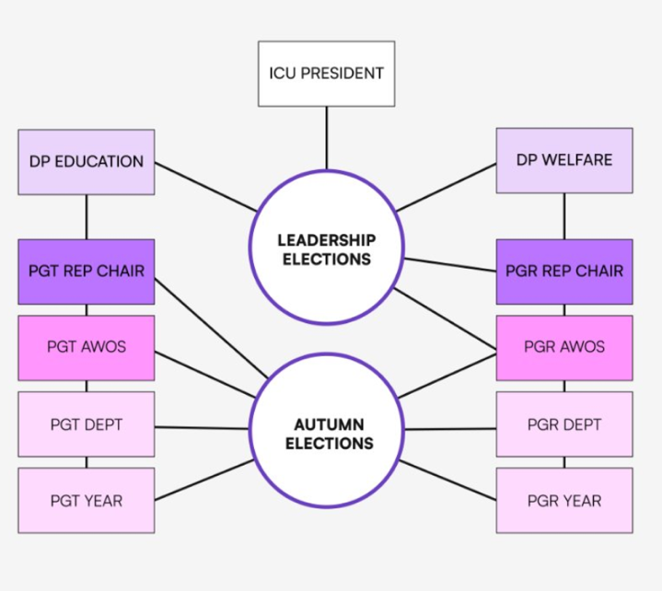
- Multiple meetings were held with staff responsible for the postgraduate experience, including those who chaired Staff–Student Liaison Committees across all faculties. Separate discussions were conducted with each Constituent Union President (RCSU, CGCU, RSMU, ICSMSU) to understand the governance arrangements and representation needs specific to their unions. Silwood Park, along with other satellite campuses, are not included within the scope of this work, as representation for these campuses requires broader consideration and is being taken forward separately.
- Within the Faculty of Medicine, a town hall was organised and attended by student representatives, ICSMSU leadership, and faculty staff, including key stakeholders responsible for postgraduate programme delivery.
- The Postgraduate Representation Coordinator met with Faculty of Natural Sciences stakeholders on 19th January 2026 to discuss campus-specific representation challenges at White City and Silwood Park.
- Alongside these faculty-level consultations, engagement with the Deputy President (Education) and Deputy President (Welfare) informed the suggestion to amalgamate the PG Taught Chair and PG Research Chair roles into a single Postgraduate Representation Chair position.
- The consultation was conducted across the following key dates: ICSMSU Faculty of Medicine: 24 October 2025 / ICSMSU: 31 October 2025 / ICSMSU: 25 November 2025 / RSMU: 11 November 2025 / RCSU: 9 December 2025 / CGCU: 19 December 2025 / RCSU: 19 January 2026 / Faculty of Medicine Town Hall: 14 January 2026 / Faculty of Natural Sciences: 19 January 2026.
- According to the ICU PG Engagement Report (2023), 63.6% of PGT students and 33.3% of PGR students could not identify their Constituent Union. ICU Leadership Election data showed that PGR turnout was 9.1% in 2025, compared to 54.7% for undergraduates.
- Two separate proposals have been developed and are appended to this paper: Appendix A sets out the RCSU, CGCU, and RSMU Two-Role Model; and Appendix B sets out the FoM / ICSMSU Three-Tier Structure, reflecting its unique governance arrangements.
Union Believes
- A single Postgraduate Chair role is necessary to create unified representation for both PGT and PGR students at the Imperial-wide level, ensuring clearer communication flows from senior university committees to student representatives.
- The current AWO structure operating separately from Constituent Unions has led to fragmentation and unclear escalation pathways, and has increased isolation for postgraduate students by maintaining a separate structure from all other students. The ICU PG Engagement Report (2023) found that PGR students reported social isolation and a lack of community, and that past postgraduate committee members consistently identified insufficient central ICU support as a key structural problem.
- Separate PGT and PGR representation enables officers to focus specifically on their cohort's distinct needs, creating more effective advocacy and engagement.
- Different faculties require different structures; a flexible approach that allows CUs to determine implementation details whilst maintaining consistent principles will ensure sustainability.
- Integration within Constituent Unions provides postgraduate students with access to CU facilities, resources, and infrastructure to organise events and maintain engagement with their faculty year-round, including during periods outside of term time such as summer.
- The proposed restructure results in an increase in postgraduate-specific council seats from 8 to 10. Each of RCSU, CGCU, and RSMU contribute a PGT and PGR VP or Officer, whilst ICSMSU contributes a PG President, VP PGT and VP PGR reflecting its governance arrangements. This, alongside the Postgraduate Representation Chair, strengthens PG representation on council relative to the previous AWO structure.
Union Resolves
- To approve the two-role structure (PGT and PGR, VP or Officer) for RCSU, CGCU, and RSMU, replacing the current AWO positions and integrating postgraduate representation within CU frameworks.
- To endorse delegation to CU Presidents to determine VP or Officer role type based on their CU's governance arrangements.
- The paper does not propose introducing new Postgraduate roles at Silwood or other satellite campuses, as representation for these campuses should be considered more broadly through a dedicated one-year review.
- To approve changes to Bye-Law A 1.8, 1.9, and 1.10 in respect of the removal of the AWO positions, the creation of the Postgraduate Chair, the VP PGT and VP PGR titles for RCSU, CGCU, and RSMU, and the PG President, VP PGT and VP PGR titles for ICSMSU, based on individual CU recommendation.
- To approve the three-tier representation structure for ICSMSU, reflecting the distinct governance and programme delivery arrangements of the Faculty of Medicine.
- To endorse the formalisation of six department representative positions within the Faculty of Medicine, feeding into faculty leadership.
- To approve separate PG President, VP PGT, and VP PGR roles for the Faculty of Medicine, addressing the distinct needs of taught and research postgraduate cohorts.
- To endorse the facilitation of 5 a faculty-level pre-meeting structure and termly UG-PG coordination meetings as part of the FoM PG President role description.
- To approve Bye-Law F 1.4 and 1.5 in relation to the creation of the Postgraduate Chair as an Officer of the Union and the addition of the ICSMSU PG President, VP PGT and VP PGR, and the PGT and PGR VP or Officer roles for RCSU, CGCU, and RSMU as Officers of the Union.
- To approve the Postgraduate Representation Chair as a unified Imperial-wide position, creating consistent communication flows from senior university committees to both PGT and PGR student representatives across all faculties.
- To endorse the current Postgraduate Taught and Research Chairs and Academic and Wellbeing Officers until the end of their term with the new Postgraduate Representation roles due to be elected in the Autumn elections.
Reference:
- Advance HE (2023) Postgraduate Research Experience Survey 2023. Available at: https://www.advance-he.ac.uk/knowledge-hub/postgraduate-research-experience-survey-2023 (Accessed: 27 January 2026).
- QAA Scotland (2023) Focus On: Student Representation for PGRs. Available at: https://www.qaa.ac.uk/scotland/focus-on/the-postgraduate-research-(pgr)-student-experience/student-representation-for-pgrs (Accessed: 27 January 2026).
- sparqs (Student Partnerships in Quality Scotland) (2018-2024) Engaging Postgraduate Students: Resources and Training Materials. Available at: https://www.sparqs.ac.uk/institute.php?page=700 (Accessed: 27 January 2026).
- Winter, J., Barton, G. and Allison, J. (2024) 'Student academic representation in the UK: An exploration of recruitment, training, and impacts', Higher Education Quarterly, 78(4). doi: 10.1111/hequ.12548.

